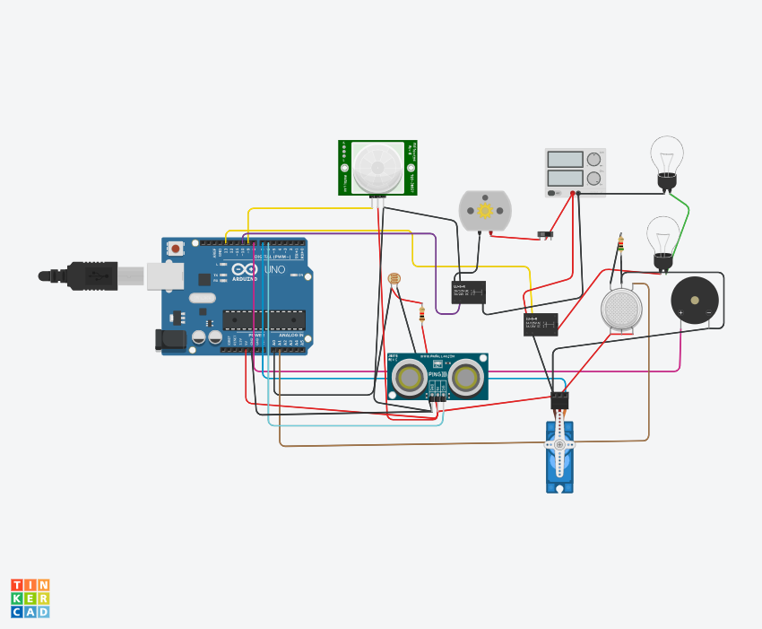

<https://www.tinkercad.com/things/cb5b6bPiVdm-assignment-1/editel?sharecode=2rE_qQd0agD-HNVI3Fy0DGt7YyfvCx5oqzR4rqfuNMI>

Code:

#include <Servo.h>

int output1Value = 0;

int sen1Value = 0;

int sen2Value = 0;

int const gas_sensor = A1;

int const LDR = A0;

int limit = 400;

long readUltrasonicDistance(int triggerPin, int echoPin)

{

pinMode(triggerPin, OUTPUT);

digitalWrite(triggerPin, LOW);

delayMicroseconds(2);

digitalWrite(triggerPin, HIGH);

delayMicroseconds(10);

digitalWrite(triggerPin, LOW);

pinMode(echoPin, INPUT);

return pulseIn(echoPin, HIGH);

}

Servo servo_7;

void setup()

{

Serial.begin(9600);

pinMode(A0, INPUT);

pinMode(A1,INPUT);

pinMode(13, OUTPUT);

servo_7.attach(7, 500, 2500);

pinMode(8,OUTPUT);

pinMode(9, INPUT);

pinMode(10, OUTPUT);

pinMode(4, OUTPUT);

pinMode(3, OUTPUT);

}

void loop()

{

int val1 = analogRead(LDR);

if (val1 > 500)

{

digitalWrite(13, LOW);

Serial.print("Bulb ON = ");

Serial.print(val1);

}

else

{

digitalWrite(13, HIGH);

Serial.print("Bulb OFF = ");

Serial.print(val1);

}

sen2Value = digitalRead(9);

if (sen2Value == 0)

{

digitalWrite(10, LOW);

digitalWrite(4, HIGH);

digitalWrite(3, LOW);

Serial.print(" || NO Motion Detected " );

}

if (sen2Value == 1)

{

digitalWrite(10, HIGH);

delay(5000);

digitalWrite(4, LOW);

digitalWrite(3, HIGH);

Serial.print(" || Motion Detected! " );

}

int val = analogRead(gas_sensor);

Serial.print("|| Gas Sensor Value = ");

Serial.print(val);

if (val > limit)

{

tone(8, 650);

}

delay(300);

noTone(8);

sen1Value = 0.01723 * readUltrasonicDistance(6, 6);

if (sen1Value < 100)

{

servo_7.write(90);

Serial.print(" || Door Open! ; Distance = ");

Serial.print(sen1Value);

Serial.print("\n");

}

else

{

servo_7.write(0);

Serial.print(" || Door Closed! ; Distance = ");

Serial.print(sen1Value);

Serial.print("\n");

}

delay(10);

}